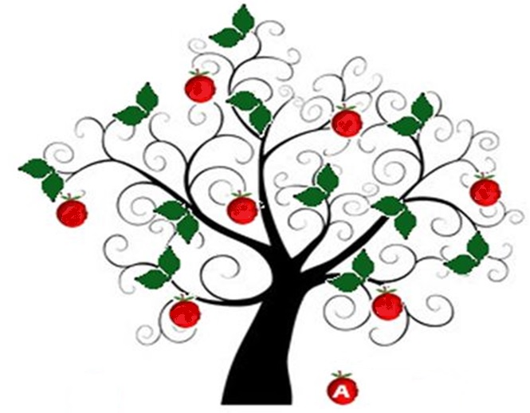
From small seeds, great trees grow.

To be reviewed January 2017

Early Years Foundation Stage Policy
January 2016

Aims
- To give each child a happy, positive and fun start to their school life in which they can establish solid foundations on which to expand and foster a deep love of learning;
- To offer each child a wide range of new and exciting experiences and give them the opportunity to consolidate, explore and test them out along with their own, individual experiences;
- To enable each child, through encouragement and high expectations, to develop, to the full, socially, physically, intellectually and emotionally.
- To offer a structure for learning that has a range of starting points and unlimited opportunity for development;
- To encourage children to develop independence within a loving, secure and friendly atmosphere;
- To support children in building relationships through the development of social skills such as cooperation and sharing;
- To help each child to recognise their own strengths and achievements through experiencing success and developing the confidence to work towards personal goals.
The curriculum the Nursery follows is as outlined in the Early Years Foundation Stage (EYFS) document, which is available from the school office or to download at https://www.gov.uk/government/uploads/system/uploads/attachment_data/file/299391 /DFE-00337-2014.pdf.
This clearly defines what we teach. The following policy details the specifics of our setting.
The EYFS framework includes seven areas of learning and development, all of which are seen as important and interconnected but three areas are seen as particularly important for igniting children’s curiosity and enthusiasm for learning, for building their capacity to learn and form relationships and thrive (DfE 2014: 1.3), they support children’s learning in all other areas, they are known as the prime areas.
The prime areas are;
- Communication and Language – Listening and Attention, Understanding and Speaking
- Physical Development – Moving and Handling and Self care
- Personal, Social and Emotional Development – Making relationships, Managing feelings and behaviour and Self-confidence and Self-awareness.
The specific areas of learning develop essential skills and knowledge for children to participate successfully in society. The specific areas are;
- Literacy – Reading and Writing
- Mathematics – Numbers and Space, Shape and Measures
- Understanding the World – People and communities, The world and Technology
- Expressive Arts and Design – Exploring and using media and materials and Being Imaginative EYFS Policy January 2015 2 Characteristics of Effective Learning

The EYFS also includes the characteristics of effective teaching and learning.
The Nursery teachers plan activities within the classrooms with these in mind. They highlight the importance of a child’s attitude to learning and their ability to play, explore and think critically about the world around them.
The three characteristics are;
- Playing and Exploring – children investigate and experience things, and ‘have a go’
- Active Learning – children concentrate and keep on trying if they encounter difficulties, and enjoy achievements
- Creating and Thinking Critically – children have and develop their own ideas, make links between ideas, and develop strategies for doing things.
Teaching strategies
We ensure there is a balance of adult led and child initiated activities across the day. Although much of the time is spent with children self-selecting tasks, the interaction between the adult and child is essential as the adult’s response to children builds understanding and therefore guides new learning.
The adult’s role is to continually model, demonstrate and question what the child is doing. In some cases the adult will ask a child to come and complete a task or game with them; at other times they will participate in a child’s game, extending it where possible.
Play Learning through play is an important part of our Early Years classrooms. We believe children learn best from activities and experiences that interest and inspire them. Using children’s interests as a starting point, we provide children with stimulating, active play experiences in which they can explore and develop their learning to help them make sense of the world.
They have opportunities through their play to think creatively and critically alongside other children as well as on their own. They are able to practise skills, build upon and revisit prior learning and experience at their own level and pace.
Play gives our children the opportunity to pursue their own interests and inspire those around them.
The children learn to adapt, negotiate, communicate, discuss, investigate and ask questions. We believe it is important that adults take an active role in child initiated play through observing, modelling, facilitating and extending their play.
Getting the balance right between child initiated play, which is controlled, and adult led activities is very important to us.
Teaching
We include direct, carefully planned, adult led experiences for children in the form of structured adult led teaching and adult led group activities.
These are particularly important in helping children to learn specific skills and knowledge and it is often through children’s play that we see how much of this learning children have understood and taken on.
We set aside times each day when the children come together to be taught in the more traditional sense, gathered together on the carpet as a class. In these slots we focus on our topic work, maths, literacy, phonics, and stories. These sessions help to develop vital habits of learning: learning as a group, listening to the teacher, taking turns to answer, sitting still etc.
EYFS Policy January 2015 3 Reading and story play an important part of the day. We want to make sure our children have a love of books and will leave the EYFS with a bank of stories they know well, both traditional and modern classics.
We make sure there is always time for whole class story at the end of the day but also that there are many opportunities to enjoy books at other times.
Every child is given their own book bag and encouraged to take books home to share with their family.
Planning
We believe many children need to be given a starting point to learn new things and find topics are a great way to fire the imagination. Topics are usually based on the following areas of learning, ‘Understanding the World’, ‘Literacy’ and ‘Communication and Language’; the topics are flexible to ensure we also follow the children’s interests, school themes and local or national events e.g. the Olympics.
Staff plan in more detail on a weekly basis using daily notes, observations and interactions with children to inform where the learning journey should move to.
Weekly plans are available for parents in the classroom and are summarised in the weekly class newsletter.
Visits and visitors
The part that visits and visitors play in the curriculum at Abercromby Nursery School is given great emphasis. We aim to go on visits in the Summer Term; these can range from a visit to a local farm to a trip to the local museum. We actively seek parental support on trips, aiming for a ratio of one adult for two children.
For safety reasons we discourage younger siblings coming along on school trips. Visitors also really enhance a topic and we like to have ‘experts’ coming in to do activities with the children. We often ask parents if they are able (and brave enough!) to share knowledge or a skill, be it book making, weaving an owl out of willow or helping with forest school activities.
Classroom organisation
Our classrooms have defined areas with clearly labelled resources to ensure children can access them easily. Each classroom is set up in a way to provide children with experiences and activities in all of the seven areas of learning. Classrooms have a writing area, maths area, creative area, book corner, role play area, construction/small world area, outdoor area and carpeted teaching area.
A variety of activities are planned for and set up in the different areas each day. The adults move to whichever area their focus for the session/day is.
The outdoor area is an important part of the classroom with many children choosing to learn outside for much of the day. We try to ensure that the range of activities outside reflects the different curriculum areas, for example setting up quiet spaces for a maths game, reading and for construction.
In Nursery, physical activity often dominates, with climbing, running, cycling and other active games being key.
EYFS Policy January 2015 4 Each child has their own labelled peg and box in the cloakroom. We encourage children to take responsibility for keeping their clothes, book bag and work safely in one place!
Assessment, observations and portfolios
Assessment is an essential part of the learning and development of children in the EYFS. It involves practitioners observing children to understand their level of achievement, interests and learning styles, and to then shape learning experiences for each child reflecting those observations.
To ensure we have evidence of a child’s progress in the EYFS we use a range of strategies all of which come together in their individual portfolio. Where appropriate, we include individual next steps for children’s learning. These next steps are discussed by the EYFS team in informal meetings after school each day and in the weekly planning meetings, these next steps inform planning for the next day and week ahead.
Staff have their own iPad which is used to capture and note observations and next steps for learning.
On entry to Nursery we carry out baseline assessments for each child. Throughout the Early Years the Class Teacher submits end of term assessment data to the Head Teacher showing each child’s development across the seven areas of learning.
All adults within the nursery setting actively seek to form positive respectful relationships with the children in their care. The formation of healthy relationships between adults and children is essential in enabling children’s well-being now and their future successes. There are rare occasions when significant adults cannot be in the class and we aim to be consistent in who covers these absences.
Partnership with parents and carers
We believe that parents and carers are a child’s first educator and therefore work very closely to ensure they are involved in what we do with their child at school. We want parents to feel they can speak to us about their child at any time and feel comfortable in our setting. As well as the Nursery visit days we offer a Meet the Teacher sessions and organise coffee mornings.
EYFS Policy January 2015 5 When a child gains a place at Abercromby Nursery School we ask them to attend a session at the school alongside all other children who will be starting and with their parents. We give each family an ‘All About Me’ booklet to complete with their child. Over the first few days at the school we encourage parents and carers to stay for as long as they wish in the classroom to ensure the transition to the school goes smoothly. We have a slow staggered entry into Nursery.
Health & safety and safeguarding
Children learn best when they are healthy, safe and secure, when their individual needs are met, and when they have positive relationships with the adults caring for them. We follow the safeguarding and welfare requirements detailed in the Early Years Foundation Stage Statutory Guidance (2014) https://www.gov.uk/government/uploads/system/uploads/attachment_data/file/299391/DFE- 00337-2014.pdf and there is a section in our school Safeguarding Policy that directly refers to practice in the EYFS.
It is important to note that members of staff do not use their mobile phones or personal handset devices in the classroom and are prohibited from taking photographs with their personal handsets.
Members of staff do, however, use school iPads to take photographs as evidence to support the regular observation assessment cycle in the EYFS. These photographs are used in children’s portfolios, in class displays and on the school website. All parents are asked to state if they give permission for their child’s image to be used on the school website through the paperwork in their initial starter packs. We are a healthy school and our children receive milk and a daily morning snack.
Our staff model good eating habits by eating alongside the children. Children in Nursery our offered a school lunch but are given the opportunity to have a packed lunch. We have a kitchen in the Nursery which no child is allowed to enter and is secured with a safety door.
EYFS Policy January 2015 6 We take all accidents seriously and always log and phone home immediately if a child bangs their head. We apply a cold compresses.
We encourage all children to start school without nappies. We acknowledge that young children often have ‘accidents’ (i.e. wet themselves) and have stocks of spare clothes and change anyone who needs it. We ask parents to help keep our stocks of clothes high by returning anything their child has borrowed. Children are changed in the open area outside the toilets.
All large climbing equipment is checked by our site officer and fire alarms are held regularly. There is an annual external check of equipment. We school procedures for child protection (see separate policy). Vicki Quigley, teacher, is the named Child Protection Officer and all concerns are discussed with her. We have separate policies for medicine in school and off-site visits.

