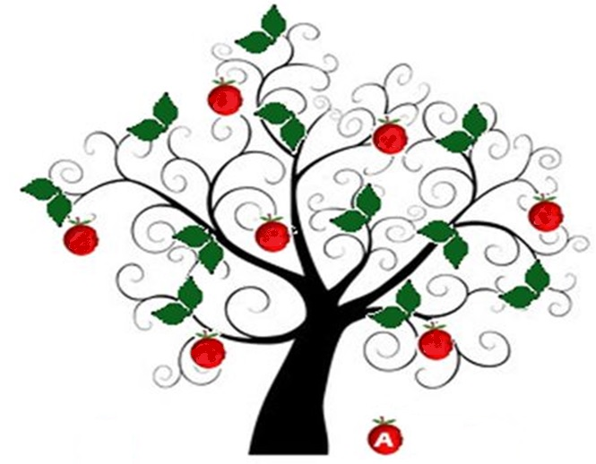
From small seeds, great trees grow.

January 2017

Teaching and Learning Policy
January 2016

At Abercromby Nursery School every child will benefit from teaching and learning of the highest quality. We expect all teaching to be good or outstanding to ensure that pupils make good progress and attain high standards.

We expect all staff to enthuse, engage and motivate pupils so that they enjoy learning and make good progress.

This policy sets out the criteria for teaching and learning.

Teachers will be given the professional responsibility to ensure that their teaching meets this standard. The head teacher, senior leadership team and other key members of staff will monitor, evaluate and review teaching and learning to ensure that this high standard is met.

This policy should be read in conjunction with the school’s policies for Performance Management and Behaviour Policy.

Objectives

- To ensure that all teaching is good or better.
- To set high expectations for pupil’s achievement.
- To ensure that all pupils benefit from teaching and learning of the highest standard.
- To continuously improve the quality of teaching and learning to increase progress and raise standards so that all pupils make good progress and attain high standards.
- To provide a basis for monitoring evaluating and reviewing teaching and learning.

Strategies

- Teachers must demonstrate high expectations by setting challenging tasks for all pupils.
- Teachers must expect and demand high standards of behaviour in all activities using praise and recognition to shape and build pupils’ positive attitudes towards learning.
- Teachers must base their teaching on the school curriculum guidelines.
- Lesson planning should have clear learning objectives to deepen pupils’ knowledge, skills and understanding.
- Learning objectives and teaching strategies should be differentiated to match pupils’ abilities and provide good opportunities for them to develop the skills needed to become independent learners.
- Appropriate teaching strategies should be used to meet the needs of pupils with SEN and disability.
- Pupils at risk of delay must be identified early and helped to successfully overcome their difficulties.
- Teachers use a wide and appropriate range of teaching and learning strategies to engage, challenge and inspire pupils of all ability levels.
- Teachers are expected to teach the EYFS curriculum.
- All teaching should include: clear explanation, good modelling of language, use of a wide range of questions, activities building on prior learning.
- Opportunities should be sought in all activities to promote pupils’ spiritual, moral, social and cultural development.
- Resources must be well managed and classrooms should be well organised, stimulating and exciting places for learning.
- Wherever possible, children should benefit from first-hand experience, opportunities for investigation, opportunities for problem solving, visits out into the environment, visitors and other activities that stimulate their learning.
- Teachers must ensure that time, support staff and other resources, especially ICT are used effectively to provide for each pupil’s individual needs.
- Teachers must assess pupils’ work thoroughly and ensure that pupils are given regular constructive feedback on their progress and standards and what they need to do to develop further.
- Teachers should work in partnership with the parents to reinforce and extend what happens at home and in school.

Outcomes

All teaching will be good or better causing pupils to make good progress and achieve high standards. This will result in pupils who:

- Enjoy teaching and learning, show interest in what they are doing, sustain concentration, are resilient and think and learn for themselves.
- Acquire and build upon skills and understanding well.
- Apply intellectual, physical or creative effort to their work.
- Are productive and work at a good pace.
- Understand what they are doing, how well they have done and how they can further develop.

