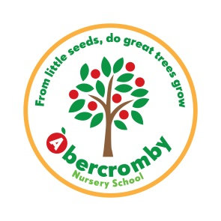
Abercromby Nursery School Uniform Order Form

Item | Price | Sizes  (Please tick) |  |  | Quantity | Total
Sweatshirt | £7.40 | 2-3 | 3-4 | 5-6
Jogging bottoms | £7.30
Cardigan | £9.50
Polo shirt | £5.25
Waterproof reversible coat | £14.40
Cap | £3.35 | One size
 |  |  |  |  | Total:

Child’s name:___________________________________________________________

Please return to office with payment.

