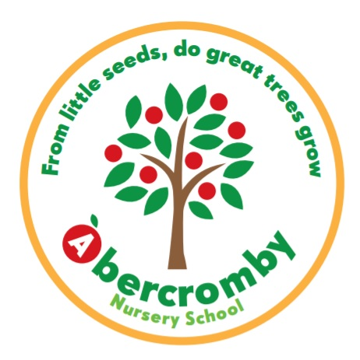

Application form for a funded (FREE) two year old place for 15 hours

To be eligible for 15 funded hours early education for a 2 year old, you must receive one of the following:

- Income Support
- Income-based Jobseeker’s Allowance (JSA)
- Income-related Employment and Support Allowance (ESA)
- Support through part 6 of the Immigration and Asylum Act
- The guaranteed element of State Pension Credit
- Child Tax Credit (but not Working Tax Credit) and have an annual income not over £16,190
- The Working Tax Credit 4-week run on (the payment you get when you stop qualifying for Working Tax Credit)
- Working Tax Credits and earn £16,190 a year or less

Children are also entitled to a place if:

- They’re looked after by a local council
- They have a current statement of special education needs (SEN) or an education health and care plan
- They get Disability Living Allowance
- They’ve left care under a special guardianship order, child arrangements order or adoption order

Please complete ALL sections:

Child’s full name

Child’s date of birth

Child’s address

Parent’s full name

Parent’s date of birth

National Insurance number

Parent’s address
(if different to child’s)
Parent’s phone number
Parent’s email address

The 15 funded hours are allocated as follows:

Wednesday afternoon (1pm - 3.15pm), Thursday and Friday (8.45am - 3pm).

What date would you like your child to start?

