Early Talk Boost
This academic year we are excited to roll out the ‘Early Years Talk Boost’ programme in Oak Tree room. Early Years Talk Boost targets 3–4-year-olds with delayed language skills, helping them catch up with their peers.
Children chosen for this programme will join three fun sessions per week during circle/ story time, each lasting 15-20 minutes. Our trained Early Years Talk Boost practitioners Laura and Mandy will lead these sessions. They are packed with activities that build essential speech, language, and communication skills.
To make these sessions engaging, we received an Early Talk Boost intervention pack. These packs are full of books, puppets, and musical instruments.

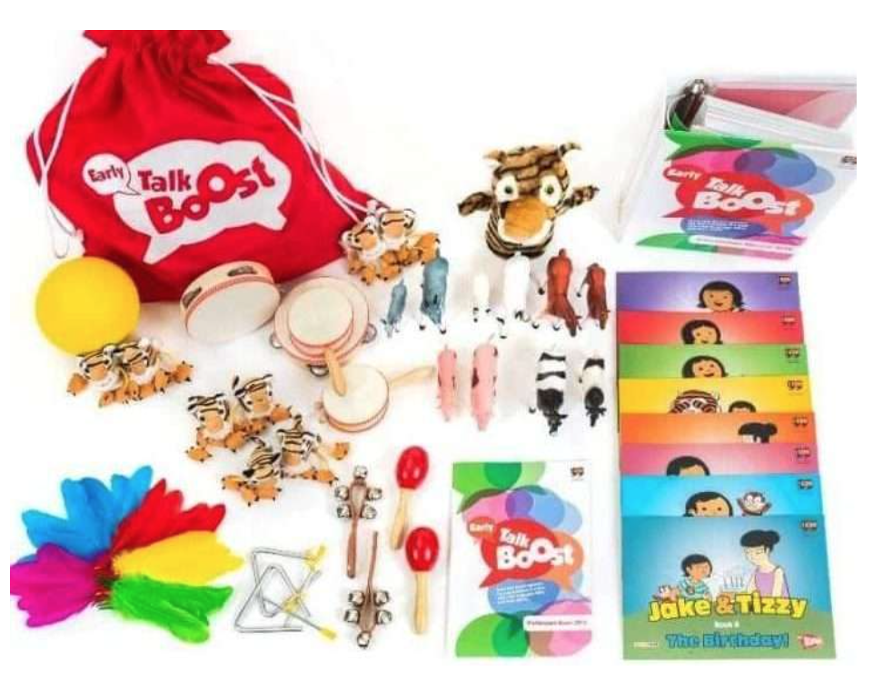

The Benefits of Early Years Talk Boost:
- Supports language development: Helps children who aren’t reaching expected language milestones.
- Enhances staff skills: Demonstrates a focus on staff development to Ofsted.
- Engages parents: Encourages parents to reinforce language skills learned in sessions.
- Complete solution: Provides a comprehensive package for speech and language support.
- User-friendly for all staff: Staff members who aren’t specialists can easily use this.
- Proven results: Improves children’s language and communication, supported by evidence.
- Sustainable: Built for repeated use with different groups.
Further information can be found in these documents and the introductory power point below:
https://speechandlanguage.org.uk/educators-and-professionals/programmes-for-nurseries-and-schools/talk-boost/early-talk-boost/

WellComm


Developing speech, language and communication skills is vital for all areas of life and can predict later school achievements and life chances from an early age. Communication is an essential foundation life skill that supports many other areas of development such as; behaviour, emotional wellbeing and lifelong learning.
At Abercromby Nursery School we support children’s speech and language development through access to high quality ‘talking environments’ from the earliest years. We use the WellComm screening toolkit to track children’s communication and language development, and provide tailored activities to develop their skills further.
Key Aspects of WellComm:
- Purpose: To screen for speech, language, and communication (SLC) needs early on and provide strategies for improvement.
- Target Age: Birth to 6 years (Early Years).
- Method: Involves observations, parent discussions, and fun tasks for children, using a color-coded system (like a traffic light) to indicate levels of concern (e.g., Green, Amber, Red).
- Support: Offers specific intervention activities and resources to support language development, often involving parents.
- Who Uses It: Early years practitioners, teachers, and speech therapists, even those without extensive prior expertise.
WellComm helps ensure children get the right communication support at the right time through easy-to-use screening and tailored interventions. If you have any concerns regarding your child’s Speech and Language development, please speak to your child’s Key Person or Natalie (SENCo).

Signalong
At our setting, all staff are trained in Signalong, a sign-supported communication system. We use simple hand signs alongside spoken words to support children’s communication and help them understand and use new vocabulary.
Signalong is used with all children and is particularly helpful for supporting early language development and inclusion.
Each week, we introduce a new sign, which will be shared with families through your child’s Learning Journal so you can see and support what your child is learning.
To find out more about Signalong and how it supports children’s communication, please visit:
👉 https://www.signalong.org.uk/why-signalong

