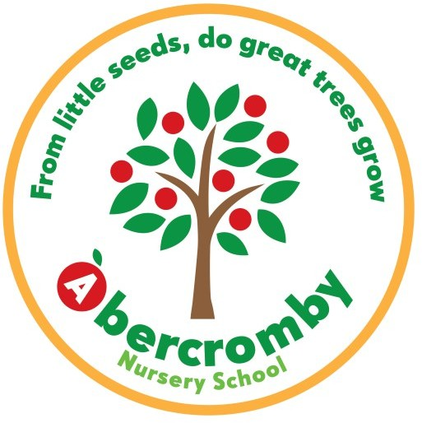
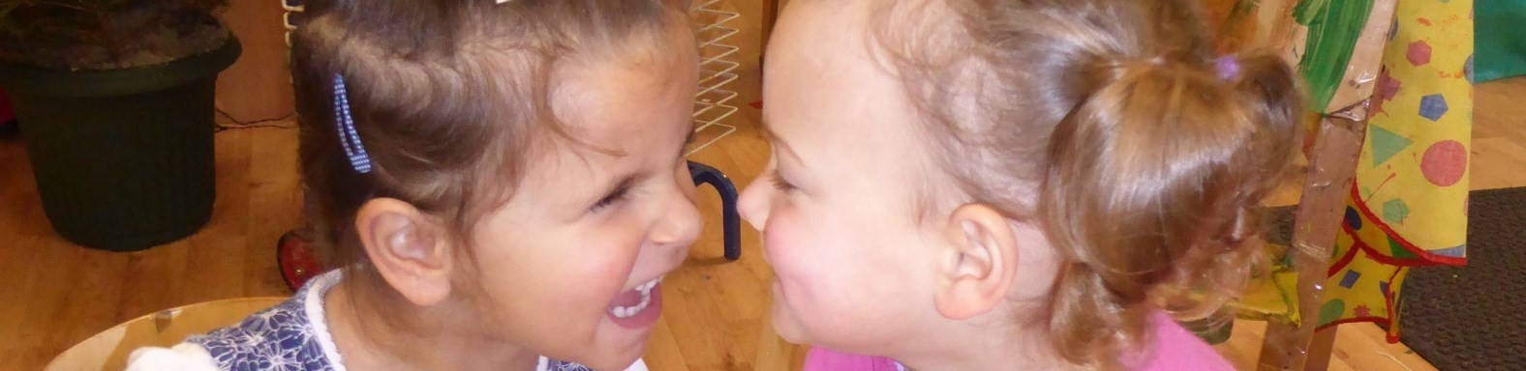
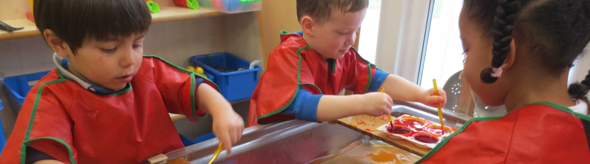
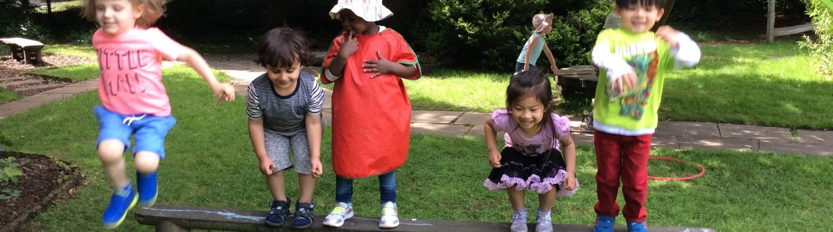
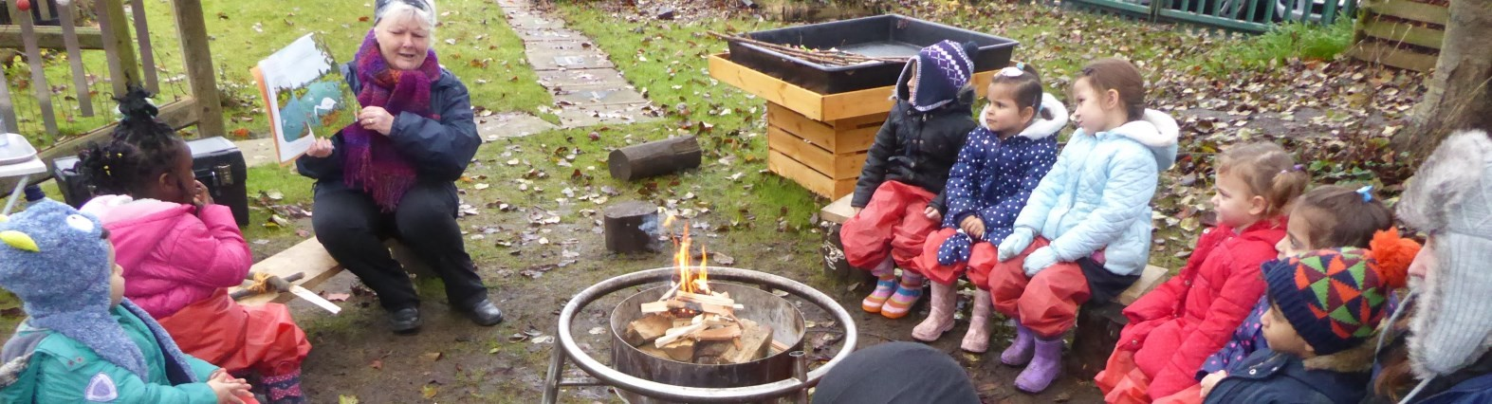

Your Child at Abercromby Nursery School

Information for Families 2026 - 2027

Welcome
Welcome to our wonderful Nursery School! We will put your child at the heart of all we do, providing a truly magical child centered education. We are so looking forward to getting to know you and your child, and working in partnership together.
Please take time to read through this booklet as it will give you information you need as your child begins their time with us. More information with photos and videos are on the website www.abercrombynurseryschool.co.uk

Session Times

WILLOW TREE ROOM (for 2-3 year olds)
We offer the funded (free) 15 hours in either morning or afternoon sessions:
- Morning place is from 8.30 am to 11.30 am
- Afternoon place is from 12.15 pm to 3.15 pm (eat lunch at home first)

OAK TREE ROOM (for 3-4 year olds)
We offer the funded (free) 15 hours in either morning or afternoon sessions:
1. Morning place is from 8.30 am to 11.30 am
2. Afternoon place is from 12.15 pm to 3.15 pm (eat lunch at home first)
We are a school, not a day nursery and so have fixed start and finish times. Regular attend- ance and good punctuality are extremely important, so that your child gets the most from their time here. PLEASE HELP US BY BEING ON TIME! Please see our Attendance and Punctuality Policy for our expectations when we offer your child a place at Abercromby.

30 HOURS PLACES
Parents of 2 to 5 year olds may be entitled to an extra 15 hours (30 hours in total) if you, and any partner, earn at least the National Minimum Wage or Living Wage and work at least 16 hours a week. Visit www.childcarechoices.gov.uk for further information and to apply. Our 30 hour places are delivered over 4.5 days. Monday – Thursday 8.30am – 3.15pm, Friday’s 8.30am – 11.30am. Please speak to staff about paying for an additional afternoon on Friday’s. .

Settling Children In

At Abercromby we have a child centered settling in procedure. This will be different for each child, as the length of time it takes to settle in is unique to each child’s needs. Please work with us as it is important that your child feels safe in the Nursery before you leave them.

Be prepared for your child to do short sessions and for you to stay with your child for the first week or maybe longer, if necessary.
You will initially need to stay with your child for their first hour and then your child will build up to staying for a morning or afternoon session, then for lunch and then finally their full sessions, as and when they feel secure enough to stay.
This will be a great opportunity for you to experience Nursery life first hand and build a relationship with your child’s Key Person, the wider Nursery Staff and to talk to staff about all your child will experience with us.
Please see our Settling In Policy for more details.

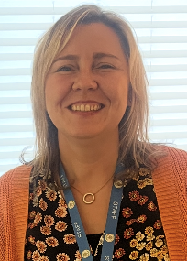
Head Teacher
Natalie Nichols

Safeguarding Lead
SENCO

 | Willow Tree 2-3 Year Olds |  | Oak Tree 3-5 Year Olds
Teachers: | Ria Humphries Deputy Safeguarding  Communication & Language Lead  First Aider |    | Laura Hutchison Deputy Safeguarding Mathematics Lead  First Aider | 
Nursery  Officers: | Salma Mohammed  Arabic interpreter  PANCO  Math’s champion  First Aider | 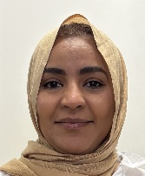 | Sofia Pinchi  Math’s Champion  First Aider | 
Nursery  Officers: | Patricia Jockins  Forest School Leader  First Aider |  | Vicky Bromsgrove  Forest School Leader  Well-Comm  First Aider | 
Nursery  Officers: | Lauren Mooney  Well-Comm practitioner  First Aider | 
 | Kadiga Mukbil  Apprentice  First Aider | 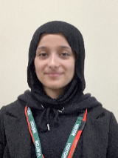
Holly Tree  (SEND Resource Base) | Mandy Corrigan  SEND Resource Base  Talk-Boost Practitioner  First Aider | 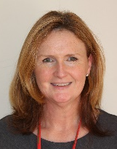
Holly Tree  (SEND Resource Base) | Dawn Cottrell  SEND Resource Base  First Aider | 

Kathy Peers  Office Manager  School Administrator  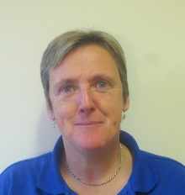 | Julie Doyle  Office Administrator and School Receptionist  First Aider  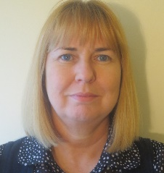 | Jez Paul  Site Manager  Defib Trained   | Martin Lancaster  PE Coach  

026/ 2027 Academic Year Dates  We are a Nursery School maintained by Liverpool Council and our holidays are the same as the local Primary Schools.  Autumn Term 2026  Starts: Thursday 3rd September  Ends: Friday 18th December  Half term: Monday 26th October to Friday 30tht October  Christmas break: Monday 21st December to Friday 1st January 2027  Spring Term 2027  Starts: Monday 4th January  Ends: Thursday 25th March  Half term: Monday 15th to Friday19th February  Easter break: Friday 26th March to Monday 12th April  Summer Term 2027  Starts: Monday12th April  Ends: Tuesday 20th July  May Day: Monday 3rd May  Half term: Monday 31st May to Friday 4th June  INSET Days (training for staff so children are not in)  1st, 2nd September, 12th February, 7th June, 21st July | 2026/ 2027 Academic Year Dates  We are a Nursery School maintained by Liverpool Council and our holidays are the same as the local Primary Schools.  Autumn Term 2026  Starts: Thursday 3rd September  Ends: Friday 18th December  Half term: Monday 26th October to Friday 30tht October  Christmas break: Monday 21st December to Friday 1st January 2027  Spring Term 2027  Starts: Monday 4th January  Ends: Thursday 25th March  Half term: Monday 15th to Friday 19th February  Easter break: Friday 26th March to Monday 12th April  Summer Term 2027  Starts: Monday12th April  Ends: Tuesday 20th July  May Day: Monday 3rd May  Half term: Monday 31st May to Friday 4th June  INSET Days (training for staff so children are not in)  1st, 2nd September, 12th February, 7th June, 21st July

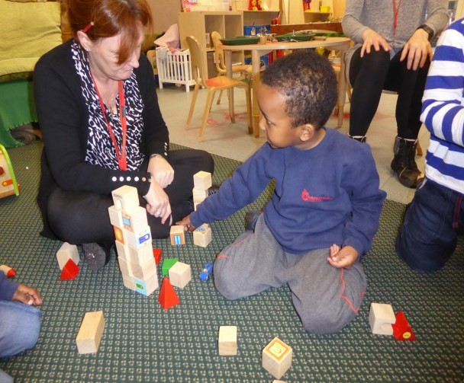
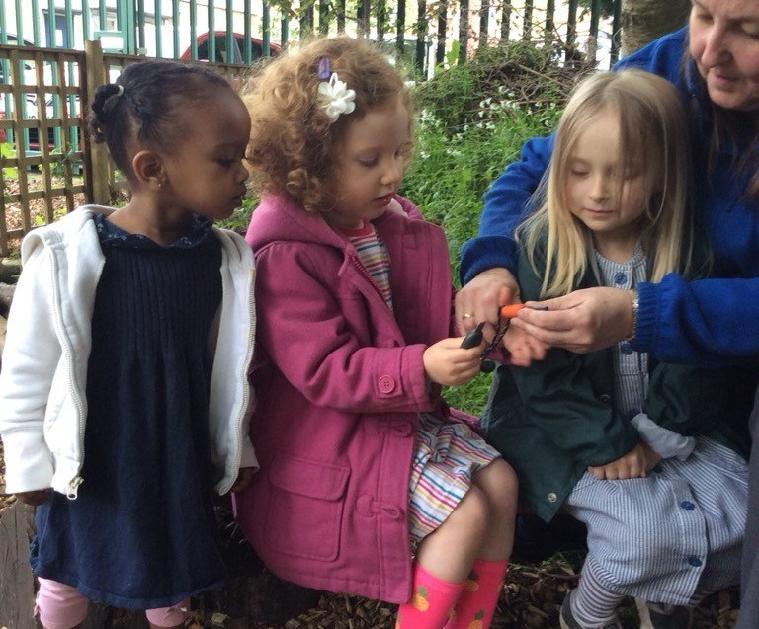
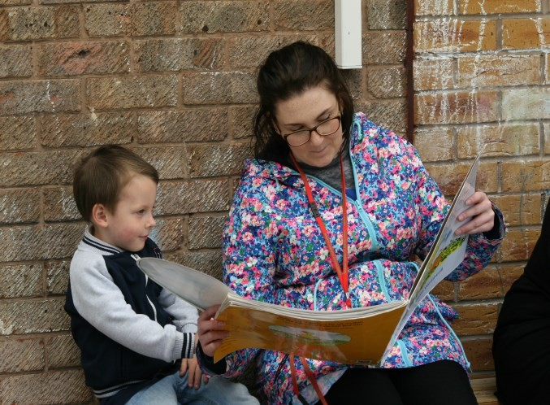
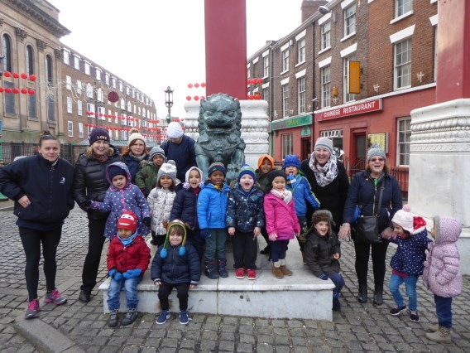
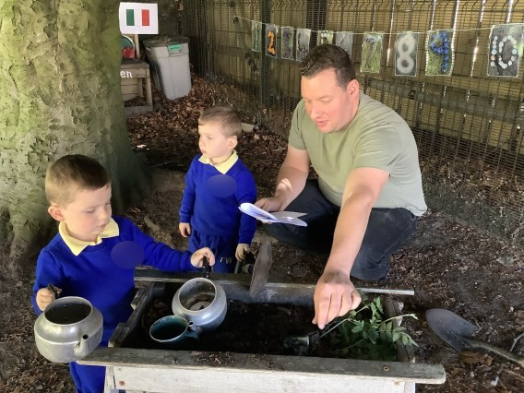
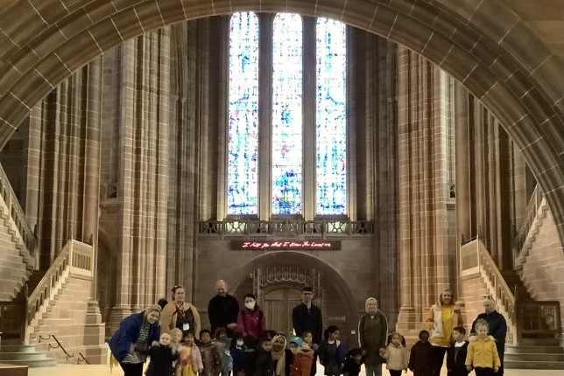
Key Person Groups
Each child will be given a Key Person as they begin their time at Abercromby, who will get to know your child really well. Their aim is to build warm and trusting relationships with your child, helping them to settle in and make secure attachments. They will get to know their personality, abilities and learning needs and will be your point of contact.
The Key Person will record your child’s learning and progress through Learning Journals, an online system, that you can see at home. They will ensure that learning and care is tailored to meet their individual needs. The Key Person will work with you to support your child’s development at home as well. They will also help families engage with more specialist support if appropriate.
Your key person will arrange regular appointments to have a chat about how your child is doing. They are usually available at the start and end of the day to share a concern or share some good news.

Working in partnership with Families
We work in partnership with you so that your child will get the most from their time with us. We use ParentHub to communicate with you and send out regular newsletters and diary dates. You can download the App so all your messages are in one place.
You can also access Learning Journals, an online system, to follow your child’s learning and achievements—and you can add your own comments and photos. Staff will inform you about what we are learning and ideas for activities for you to do at home too.
It is important that we know about any changes at home that might affect your child e.g. a new baby, pet death, family illness etc. so that we can provide support if needed.
Children have their own book bags and can borrow books from Nursery for you to read with them at home. It’s a great way to help your child to develop speaking and listening skills.
We welcome parent helpers (once your child has settled) who can support the Nursery in a variety of ways, always with lots of help and support from the staff. We also go on various outings throughout the year to enhance the children’s learning and sometimes need adults to hold the children’s hands.
Once a term we hold a “Stay, Play and Learn” session, where you are invited to attend Nursery with your child and play alongside, seeing all that your child is learning and doing. These are great fun and people always say how much they enjoy them and get ideas for how to help their children at home.

What your child will be learning
Children aged 0-5 follow the Early Years Foundation Stage or EYFS stage of learning. Four guiding principles shape our practice. These are:
- every child is a unique child, who is constantly learning and can be resilient, capable, confident and self-assured;
- children learn to be strong and independent through positive relationships;
- children learn and develop well in enabling environments, in which their experiences respond to their individual needs and there is a strong partnership between practitioners and families; and
- children develop and learn in different ways and at different rates. The framework covers the education and care of all children in early years provision, including children with Special Educational Needs and Disabilities (SEND).

OUR CURRICULUM - THE AREAS OF LEARNING AND DEVELOPMENT
There are seven areas of learning and development that shape the education we provide. All areas of learning and development are important and inter-connected. Three areas are particularly crucial for igniting children’s curiosity and enthusiasm for learning, and for building their capacity to learn, form relationships and thrive. These three areas, the Prime Areas, are:
- Personal, Social and Emotional Development
- Communication and Language
- Physical Development
We also support children’s learning in four Specific Areas, through which the three Prime Areas are strengthened and applied. The Specific Areas are:
- Literacy
- Mathematics
- Understanding the World
- Expressive Arts and Design
At Abercromby we plan for learning across all 7 areas. The programs of study are described as follows:

Personal, Social and Emotional Development
Children’s personal, social and emotional development (PSED) is crucial for children to lead healthy and happy lives, and is fundamental to their cognitive development. Underpinning their personal development are the important attachments that shape their social world. Strong, warm and supportive relationships with adults enable children to learn how to understand their own feelings and those of others. Children
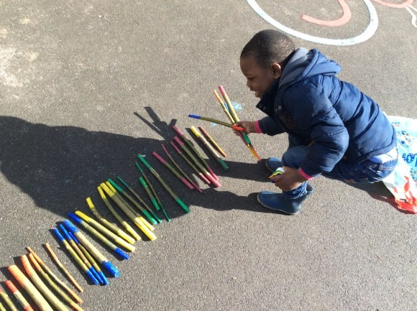
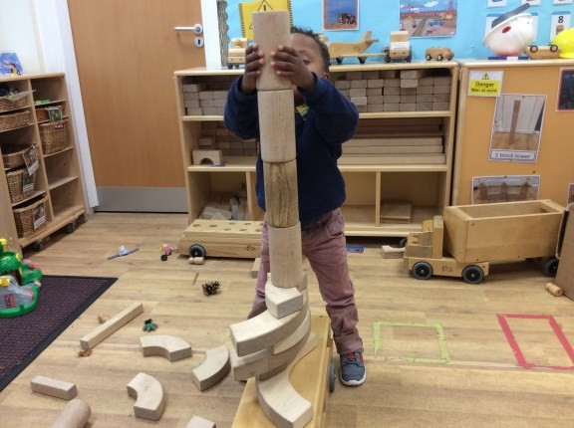
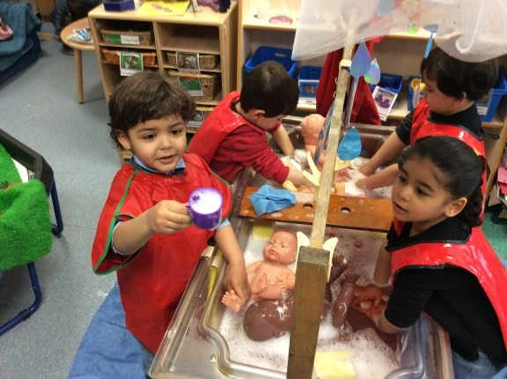

What your child will be learning
should be supported to manage emotions, develop a positive sense of self, set themselves simple goals, have confidence in their own abilities, to persist and wait for what they want and direct attention as necessary. Through adult modelling and guidance, they will learn how to look after their bodies, including healthy eating, and manage personal needs independently. Through supported interaction with other children, they learn how to make good friendships, co-operate and resolve conflicts peaceably. These attributes will provide a secure platform from which children can achieve at school and in later life.

Communication and Language
The development of children’s spoken language underpins all seven areas of learning and development. Children’s back-and-forth interactions from an early age form the foundations for language and cognitive development. The number and quality of the conversations they have with adults and peers throughout the day in a language-rich environment is crucial. By commenting on what children are interested in or doing, and echoing back what they say with new vocabulary added, practitioners will build children's language effectively. Reading frequently to children, and engaging them actively in stories, non-fiction, rhymes and poems, and then providing them with extensive opportunities to use and embed new words in a range of contexts, will give children the opportunity to thrive. Through conversation, story-telling and role play, where children share their ideas with support and modelling from their teacher, and sensitive questioning that invites them to elaborate, children become comfortable using a rich range of vocabulary and language structures.

Physical Development
Physical activity is vital in children’s all-round development, enabling them to pursue happy, healthy and active lives. Gross and fine motor experiences develop incrementally throughout early childhood, starting with sensory explorations and the development of a child’s strength, co-ordination and positional awareness through tummy time, crawling and play movement with both objects and adults. By creating games and providing opportunities for play both indoors and outdoors, adults can support children to develop their core strength, stability, balance, spatial awareness, co
-ordination and agility. Gross motor skills provide the foundation for developing healthy bodies and social and emotional well-being. Fine motor control and precision helps with hand-eye co-ordination, which is later linked to early literacy. Repeated and varied
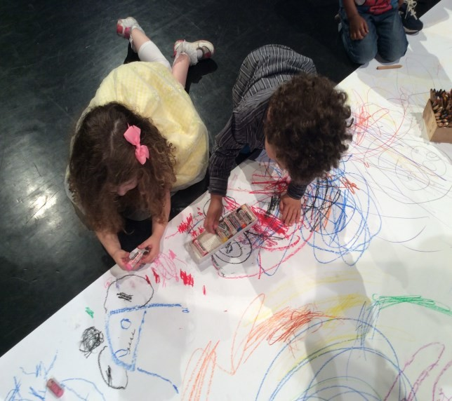
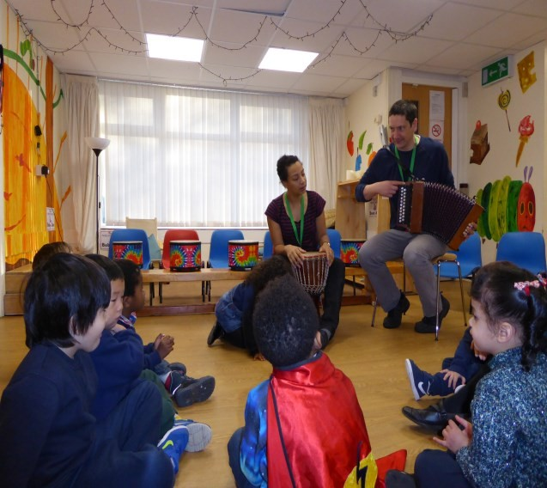
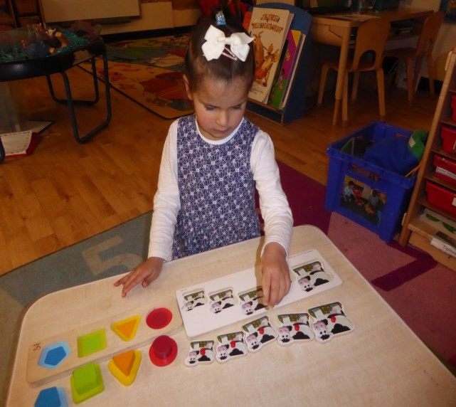

What your child will be learning
opportunities to explore and play with small world activities, puzzles, arts and crafts and the practice of using small tools, with feedback and support from adults, allow children to develop proficiency, control and confidence.

Literacy
It is crucial for children to develop a life-long love of reading. Reading consists of two dimensions: language comprehension and word reading. Language comprehension (necessary for both reading and writing) starts from birth. It only develops when adults talk with children about the world around them and the books (stories and non-fiction) they read with them, and enjoy rhymes, poems and songs together. Skilled word reading, taught later, involves both the speedy working out of the pronunciation of unfamiliar printed words (decoding) and the speedy recognition of familiar printed words. Writing involves transcription (spelling and handwriting) and composition (articulating ideas and structuring them in speech, before writing).

Mathematics
Developing a strong grounding in number is essential so that all children develop the necessary building blocks to excel mathematically. Children should be able to count confidently, develop a deep understanding of the numbers to 10, the relationships between them and the patterns within those numbers. By providing frequent and varied opportunities to build and apply this understanding - such as using manipulatives, including small pebbles and tens frames for organising counting - children will develop a secure base of knowledge and vocabulary from which mastery of mathematics is built. In addition, it is important that the curriculum includes rich opportunities for children to develop their spatial reasoning skills across all areas of mathematics including shape, space and measures. It is important that children develop positive attitudes and interests in mathematics, look for patterns and relationships, spot connections, ‘have a go’, talk to adults and peers about what they notice and not be afraid to make mistakes.

Understanding the World
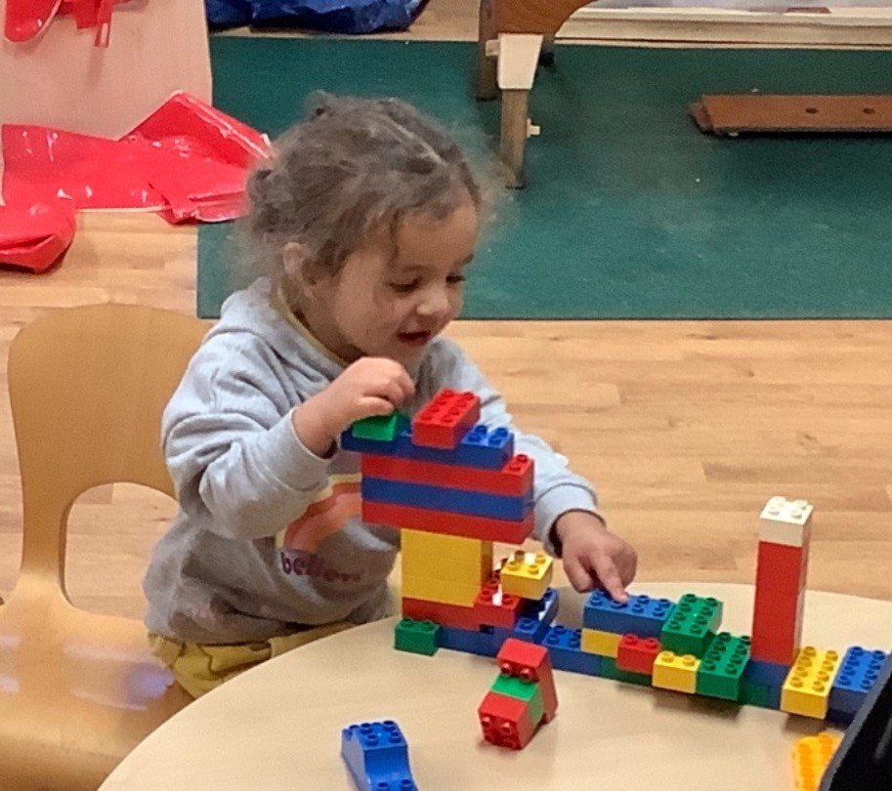
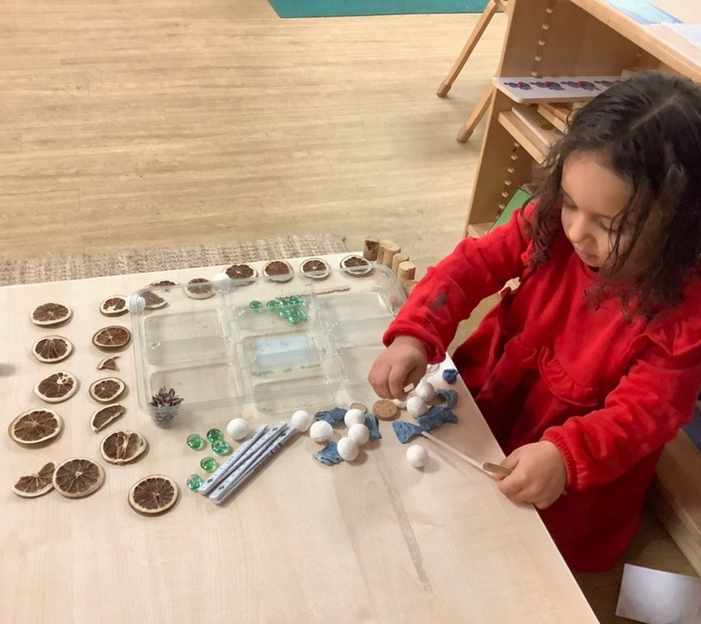
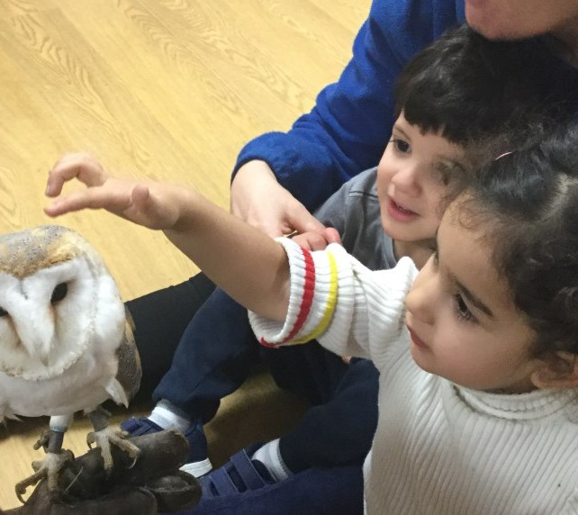
Understanding the world involves guiding children to make sense of their physical world and their community. The frequency and range of

What your child will be learning
children’s personal experiences increases their knowledge and sense of the world around them – from visiting parks, libraries and museums to meeting important members of society such as police officers, nurses and firefighters. In addition, listening to a broad selection of stories, non-fiction, rhymes and poems will foster their understanding of our culturally, socially, technologically and ecologically diverse world. As well as building important knowledge, this extends their familiarity with words that support understanding across domains. Enriching and widening children’s vocabulary will support later reading comprehension.

Expressive arts and design
The development of children’s artistic and cultural awareness supports their imagination and creativity. It is important that children have regular opportunities to engage with the arts, enabling them to explore and play with a wide range of media and materials. The quality and variety of what children see, hear and participate in is crucial for developing their understanding, self-expression, vocabulary and ability to communicate through the arts. The frequency, repetition and depth of their experiences are fundamental to their progress in interpreting and appreciating what they hear, respond to and observe.

CHARACTERISTICS OF EFFECTIVE TEACHING AND LEARNING
When planning and guiding children’s activities, we reflect on the different ways that children learn. This is about helping children to develop their skills and abilities and to see themselves as competent learners. The three characteristics of effective teaching and learning are described as:

playing and exploring
children investigate and experience things, and ‘have a go’

active learning
children concentrate and keep on trying if they encounter difficulties, and enjoy achievements

creating and thinking critically
children have and develop their own ideas, make links between ideas, and develop strategies for doing things

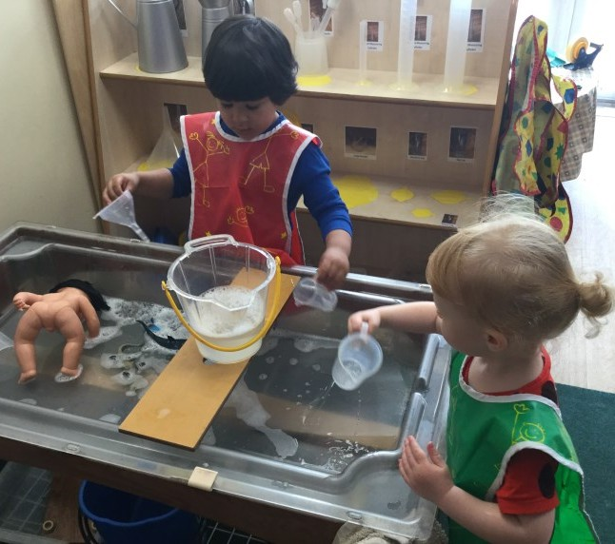
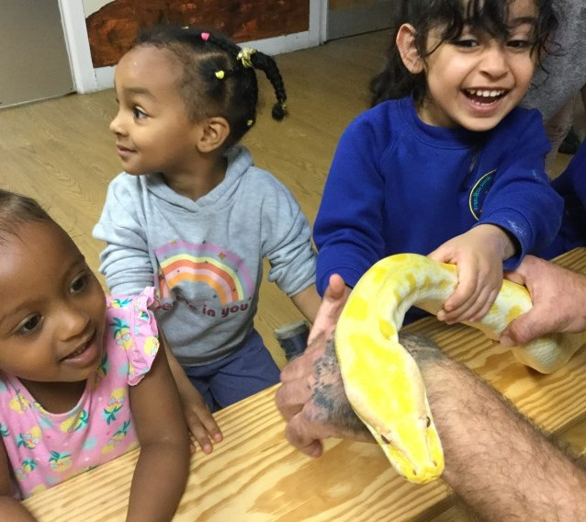
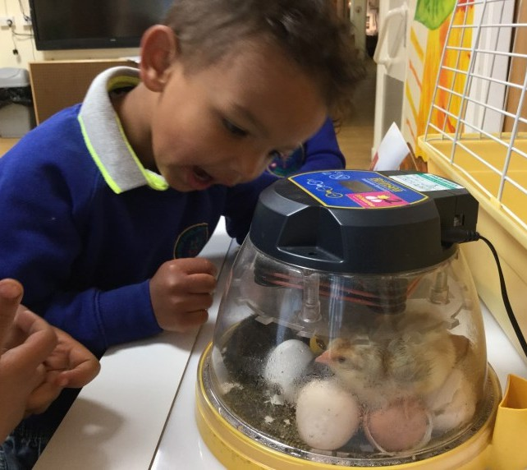

Curriculum Enhancement
Children at Abercromby have the chance to take part in various enrichment activities:

Forest School
In Forest School children learn about the natural environment, how to handle risks and use their own initiative to solve problems and cooperate with others. We want our children to develop a love and appreciation of nature as we know this will help their mental health and wellbeing.
During the sessions, children will build and light a fire and often cook food to share with the rest of the school. They might build shelters and use woodwork skills to create and build objects from the natural environment.
It offers all our children opportunities to develop confidence and self-esteem and to
experience managing risks successfully.
All Forest School sessions take place in the wild part of our lovely spacious garden and are fully risk assessed.

Physical Education (PE) with Martin
This takes place on Wednesdays and is led by Martin, a PE specialist. The children take part in small groups and Martin plans games and activities to develop their coordination, balance and core strength. They learn how to jump hurdles and balance on wobble boards. They play target games with bean bags and ball games.

Nappies and Toileting
If your child is still in nappies, you will need to bring in a supply of nappies and wipes, which we will keep in their own basket, just for them to use. When a child is showing signs of being ready to come out of nappies, e.g. telling us when they are doing a wee or a poo, we will work with you to support their toilet training.
Once a child is out of nappies, they may still have accidents and so we ask you to bring a bag of spare clothes, to hang on their peg. They may also get wet playing in the water or muddy in the garden and so it is nice for them to have their own clothes to change in to.

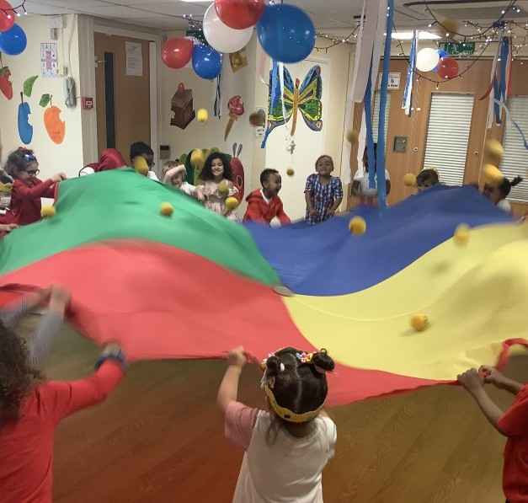
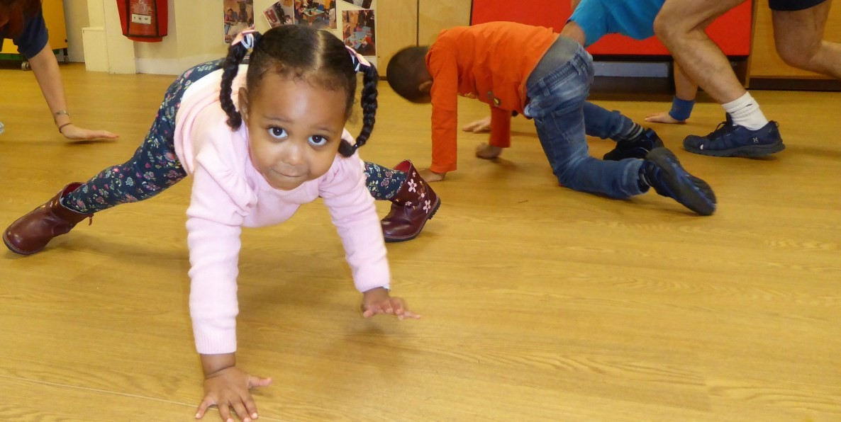
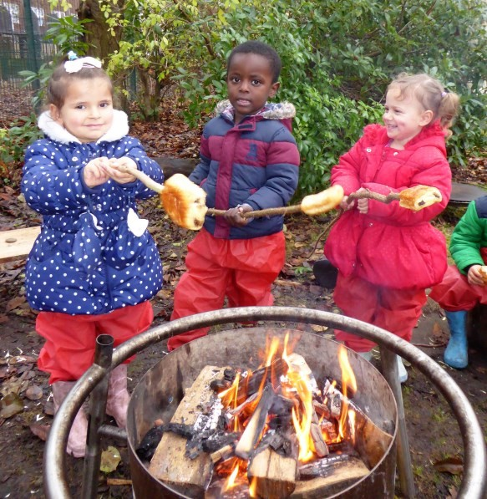

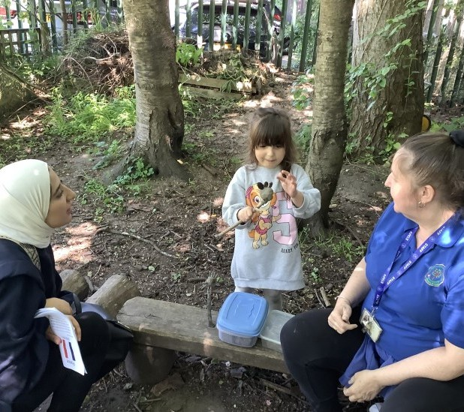
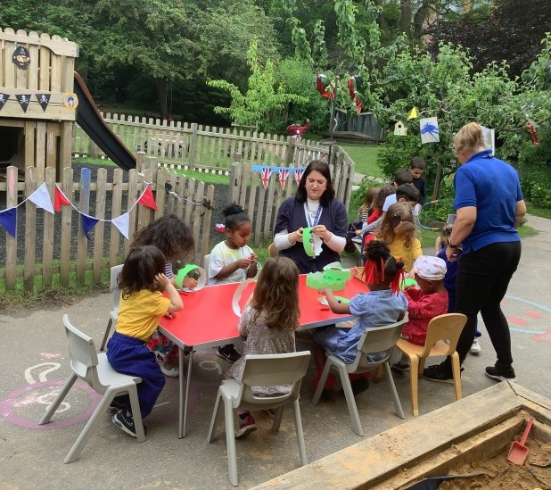
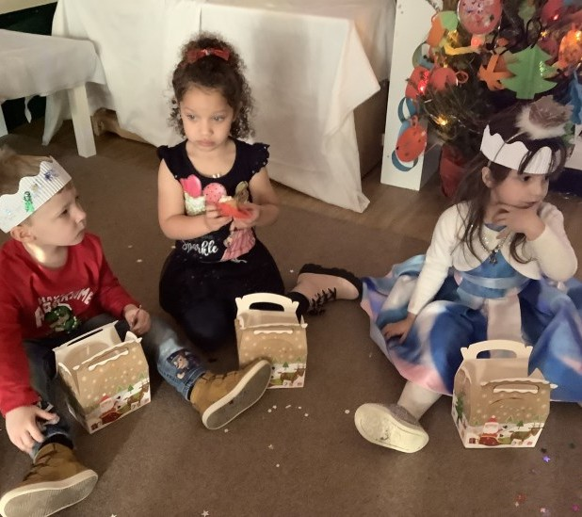
Dropping Off / Picking Up / Lateness

As we start activities with the children soon after they arrive, the children must arrive on time. They need the settling in time at the start of their day and the chance to take part in targeted small group activities and teaching time, which is important to their education.
We finish the end of the session with story and rhymes, again important to your child’s learning, so please do not arrive early to pick your child up. Also please don’t be late! It is really important to collect your child on time, as they can get very tearful if someone is late. In addition, the staff have training, meetings and jobs to do after school.
If for some reason you are genuinely unavoidably late, please ring the office and we can reassure your child that you are on your way.
We need the names and contact details for people who are authorised to pick your child up. We need at least 3 contacts. Please let us know in advance if someone other than the usual adult is collecting your child, otherwise for safety reasons we cannot let them go.
An adult (at least 16 years old) must always collect children. We also use a password system for extra security e.g. if someone new is collecting your child.
Please note that the office staff will always phone you if we don’t recognise the person asking to collect your child. The safety of the children is of utmost importance to us.

Absence, Illness and Allergies

If children have been unwell, please keep them at home until they are well enough to attend nursery and always 48 hours after they have been sick or had diarrhoea. Germs spread quickly through a group of children. In addition your child will not be able to enjoy school if they are not feeling themselves.
Please phone us or report an absence on ParentHub before 9.30am if your child is not able to attend for any reason.
If your child has asthma, we can keep spare inhalers for them in nursery; you will need to sign a consent form for this. Please speak to us if your child has any needs, which you think we should be aware of.
Please see our ‘Child Absence and Punctuality’ sheet for more information.
We need to know if your child has any allergies or dietary requirements. With your permission, we will make photo signs to place in key areas so all staff are aware of this. They can then keep children safe and respect family wishes e.g. if a child is allergic to peanuts or is a vegetarian. We make sure we only provide snacks suitable for all our children, many of whom come from different religious backgrounds.

Clothing
If a child wears their own clothes in nursery, please do not send them in anything special, as It will get covered in paint, mud, sand, playdough etc. even though we use aprons for messy activities.
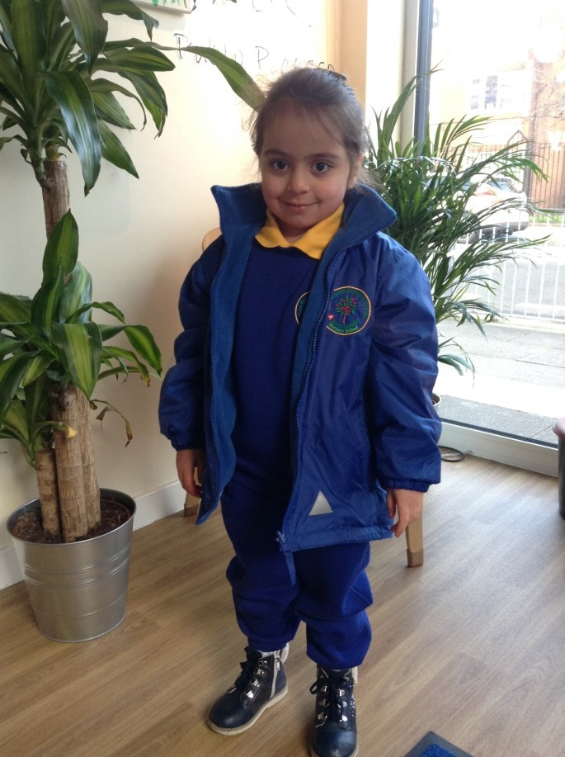
It is also important that your child has clothes that they can manage all by themselves in the toilet e.g. that they can pull up and down independently - i.e. no dungarees, belts, tight fitting jeans or trousers, or fiddly tights for younger girls.
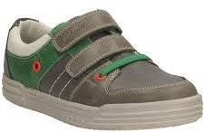
School uniform is not compulsory but it is available and can be ordered from the office.
Our school uniform is as follows:
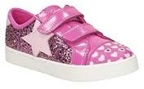
Gold polo shirt (school logo) Blue sweatshirt (school logo) Jogging bottoms
Woolly hat/cap (school logo)
Sensible ‘safe’ shoes with Velcro fastening that support children as they run and climb outside-no laces, crocs or sandals please.

All clothes must have the child’s name clearly written in them with a name tape or with a laundry marker (there may be 100 identical sweatshirts in Nursery by the end of the year!).
We play outside in most types of weather so please make sure that your child is prepared - coat, hat, and mittens (easier than gloves!) in Winter, sun cream and sun hats in the Summer.
Make sure they wear waterproof coats and wellies on a rainy day.
Please bring in some spare clothes in a bag (drawstring style bag) in case of accidents.
If your child has to borrow nursery spares then please wash and return them quickly.
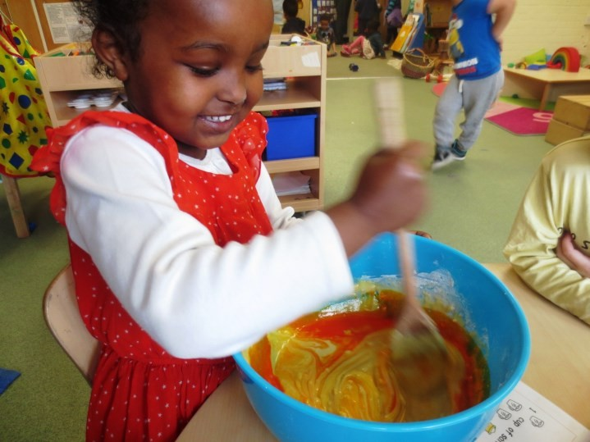
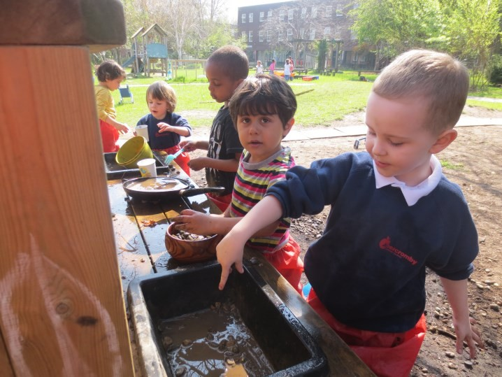
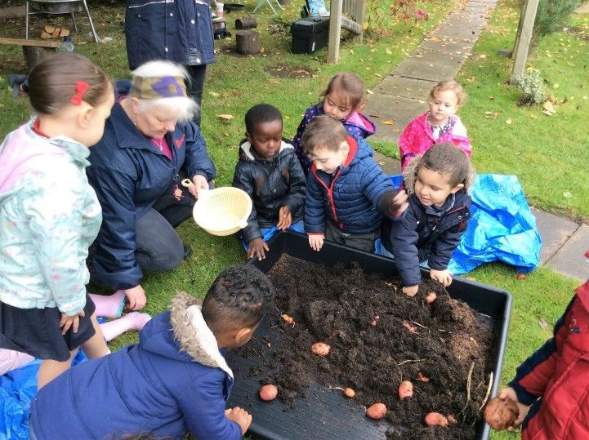
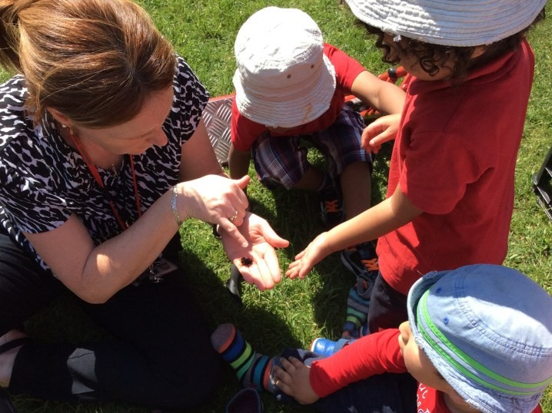

Snacks
The children will be offered snacks and fruit through the day. As part of learning to be independent they choose when to come and have their snack, help themselves to what they want and clear it away afterwards.
There is a choice of milk or water to drink and food served includes healthy snacks such as cereal, toast, fruit, cheese, breadsticks etc. Sometimes we may try exciting things such as Chinese food to celebrate Chinese New Year or we may bake cakes or make soup.
We ask for a weekly voluntary contribution of £1 for part time children and £2 for full time children, payable to your child’s room, to the office or via BACS.

Packed Lunch
Children who stay all day (30 hours) will need a packed lunch in a named lunch box/bag. We would like to offer the following guidelines for a healthier packed lunch:
- We don’t have anywhere to keep lunches cool, so please do not put in food that may spoil.
- We cannot heat up food brought from home
- We provide water for all our children so no drinks are required. We encourage the children to drink lots of water to help them concentrate and feel well
- Include some foods high in carbohydrates such as bread, pasta, wraps or rice
- Add some protein such as chicken, turkey, ham, eggs, tofu, cheese, or beans
- Add some vegetables such as carrot sticks, tomatoes, cucumber; fresh fruit such
as apple, banana or pear; or dried fruit such as raisins or apricots
- If you provide grapes, please cut them in half lengthways, as whole grapes are a choking risk for small children
- You can include a dairy product or dairy alternative, such as fromage frais or yoghurt.
- Please do not bring in crisps, chocolate or biscuits. These foods tend to be high in fat, sugar and salt, causing weight gain, possibly leading to heart disease. High sugar foods are high in calories and are bad for teeth.
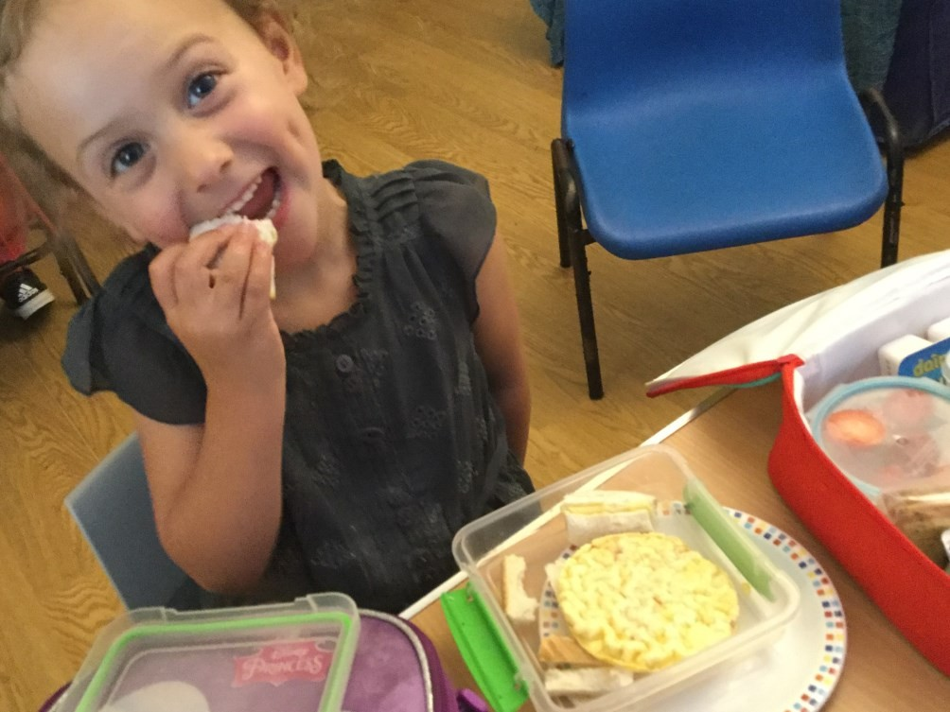
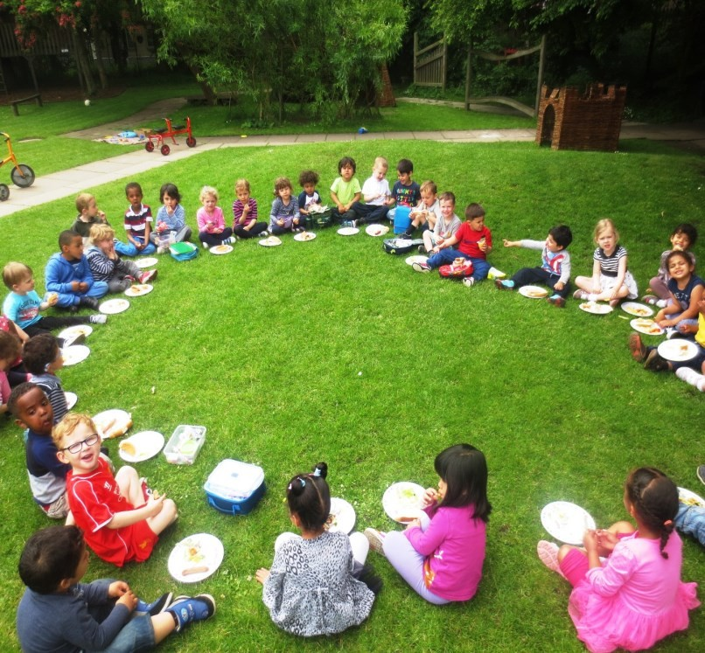

Behaviour Policy
We believe in helping the children form good relationships with other children and adults, developing an understanding of what is right and wrong, and why. For most children, this is the first time they have had to learn to be part of a large group. Staff support the children sensitively, helping them to understand how to be part of a community. We recognise that all behaviour is communication and that children need understanding to manage their big emotions. For example, we don’t use the word “tantrum”, instead we recognise that a child has become distressed and dysregulated, needing our support.
It is very common for there to be disagreements and for children to be physical with each other until they learn how to get on with others. We encourage the children to take turns, share fairly, look after equipment and resolve conflict through talking (and not hitting).
The children help to think of some simple rules, which help everyone to feel happy and
safe. They might include;
- We walk inside – we can run outside
- We use quiet voices inside – we can shout outside
- We look after our Nursery – and help tidy things away
- We listen when someone is talking – and put our hand up to take turns in talking
- We are kind in what we say and do
- We take turns and share
These are linked to our Abercromby Values—look at the website for more information. We reward good behaviour in many ways – with a smile or praising the improved
behaviour, and a Star of the Week award. If we feel a child is not responding to us we may give the children a couple of minutes to be quiet with an adult, after which they are encouraged to say sorry and join in again. We keep parents informed of any concerns and try and work with you towards a solution.

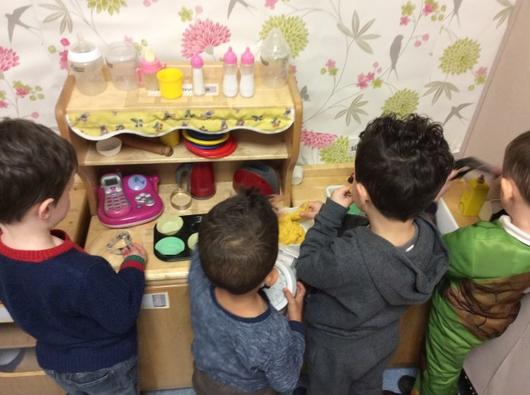
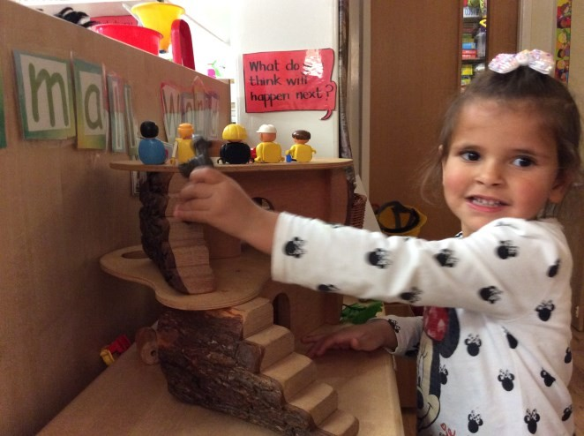
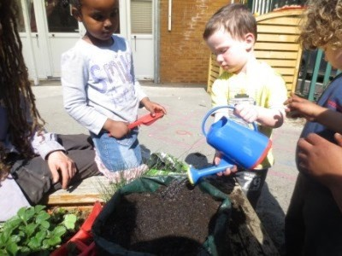

Prams / Pushchairs / Scooters / Bikes
Prams, pushchairs, scooters or bikes can be stored in the shed next to the building during the day. The shed will be locked, but any items are left entirely at your own risk.
Please do not bring prams or pushchairs inside the school as there is not enough room and it becomes a trip hazard.

Additional Information

We hope that this booklet will answer questions that you may have but please feel free to talk to any of us if you need more information.
Copies of our policy documents are available on our website or paper copies are available upon request from the office.
As a registered provider our school is regularly inspected by Ofsted, and these reports and more information are available on their website www.ofsted.gov.uk.
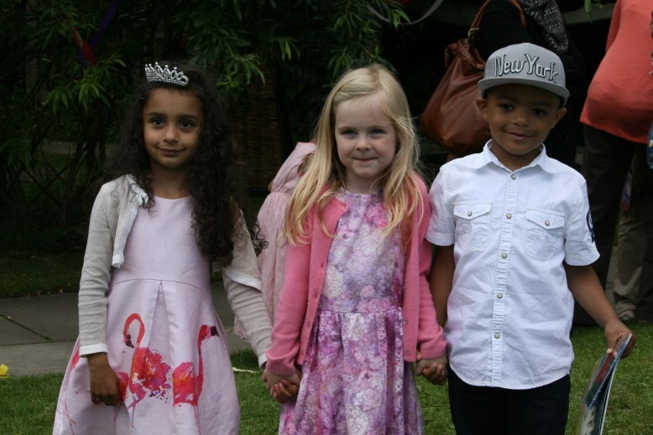
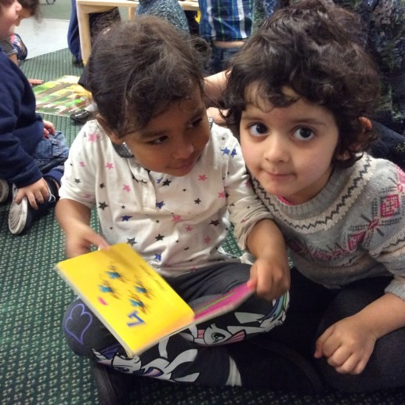
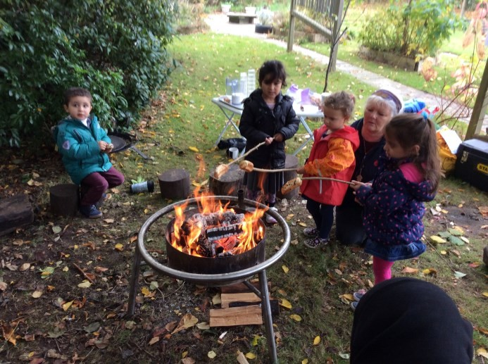
Abercromby Nursery School Falkner Street
Liverpool L8 7QA
Telephone: 0151 709 5114 www.abercrombynurseryschool.co.uk
abercromby-ao@abercromby.liverpool.sch.uk

